End-to-End Workflow of the Referral App in Odoo 19
Rohan Raj | Mar 2, 2026
Employee referrals are one of the most effective ways to hire quality talent. Current employees understand the company culture and job requirements better than anyone, making them an ideal source for recommending candidates who are likely to succeed. However, managing referrals through emails, spreadsheets and informal conversations often leads to lost recommendations, untracked progress and no incentive for employees to refer consistently.
In Odoo 19, the Referrals application solves these problems by providing a gamified, fully integrated referral system that connects directly with the Recruitment pipeline. Employees can share job openings through email, SMS, social media and tracking links, earn points as their referrals progress through recruitment stages, and redeem those points for rewards configured by the company. The entire process is tracked, measured and reported within the ERP system.

Understanding the Referral App in Odoo 19
The Referrals application in Odoo 19 is a centralized platform where employees can view open job positions, share them with their network and track the progress of their referrals. The app uses a gamification approach — employees earn referral points as their referred candidates move through the recruitment pipeline stages, and these points can be exchanged for rewards in an in-app shop.
The Referrals app integrates with the Employees, Recruitment and Website applications. The Recruitment app manages the hiring pipeline, the Employees app stores employee records, and the Website app enables online job publishing so that referral links lead to actual job listing pages where candidates can apply.
Key capabilities of the Referrals app include:
- Job Sharing — Employees can share individual job positions via email, SMS, Facebook, X, LinkedIn or a direct tracking link
- Point System — Points are earned automatically when a referred candidate progresses through recruitment stages such as Qualification, First Interview, Second Interview, Contract Proposal and Contract Signed
- Rewards Shop — Accumulated points can be redeemed for company-configured rewards such as coffee mugs, gift cards, merchandise or experiences
- Levels and Avatars — A gamification layer where employees level up through five preconfigured levels and collect superhero avatars as their referrals get hired
- Reporting — Administrators can analyse referral sources, employee performance and reward redemption through dedicated reports

Installation
The Referrals app requires three applications to be installed — Employees, Recruitment and Website. If any of these are not already installed, Odoo will install the necessary dependencies automatically when the Referrals module is activated.
Apps => Employee Referral => Install

Onboarding Experience
When an employee opens the Referrals app for the first time, a preconfigured onboarding sequence appears. This consists of four interactive slides with a superhero theme that explain how the referral program works.
The onboarding slides will continue to appear every time the Referrals app is opened until the employee clicks Start Now on the final slide. Clicking Skip at any point takes the employee directly to the main dashboard.
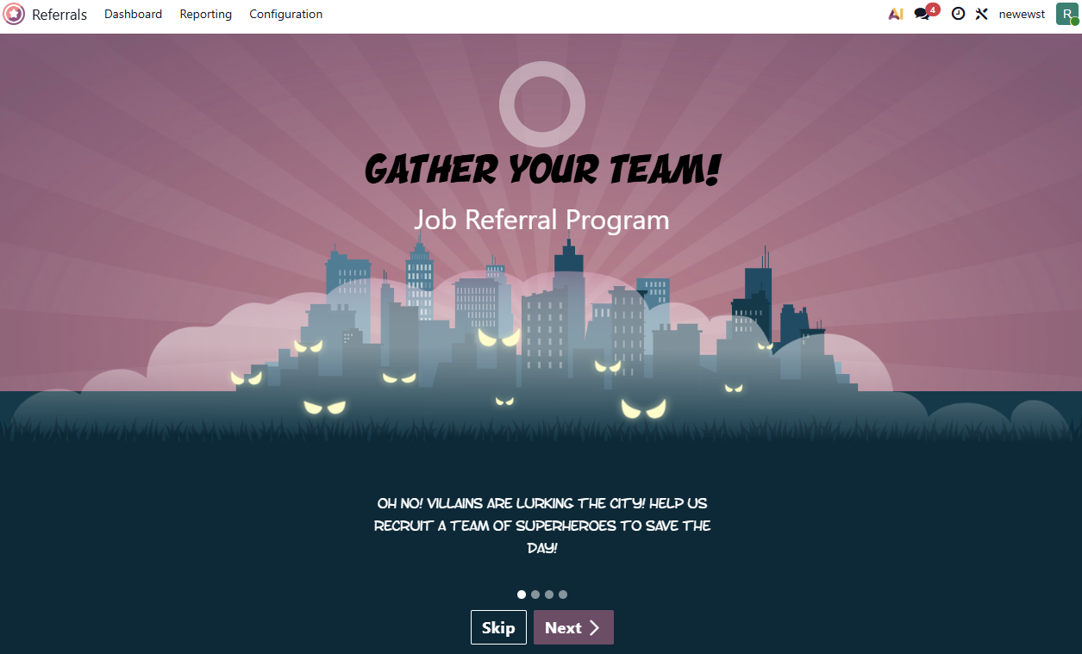
Administrators can customize the onboarding experience by modifying the slides.
Referrals Application => Configuration => Onboarding
Each slide can be edited to change the text, image and company assignment. If a company is specified on a slide, that slide is only displayed for users within that company. The order of slides can be rearranged by dragging them into the desired sequence.
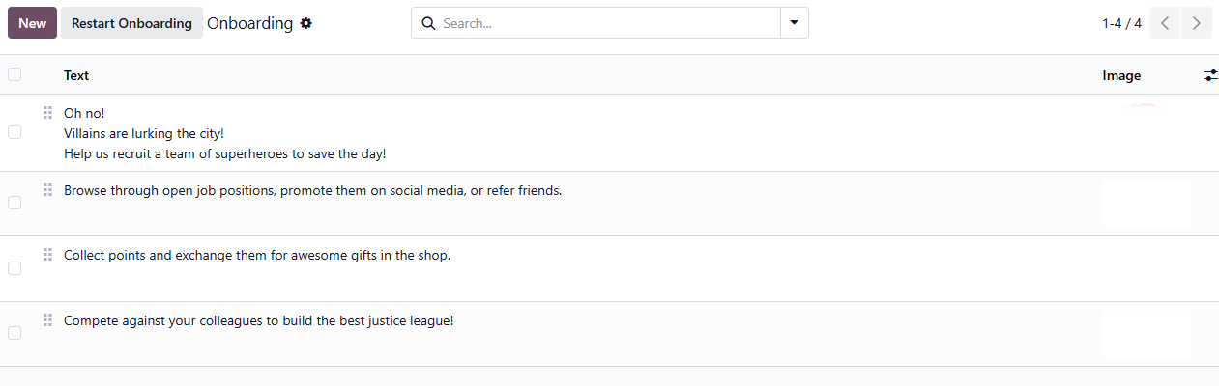

The Referrals Dashboard
The main Referrals dashboard displays the following elements:
- User Avatar — The employee's superhero avatar with their photo and current level displayed beneath it
- Points Summary — Total points earned and points available to spend
- Referral Counts — The number of total referrals, ongoing referrals (still in the pipeline) and successful referrals (hired)
- Friend Avatars — Superhero avatars representing hired referrals appear alongside the user's avatar
- Alert Banners — Any active alerts configured by administrators appear at the top of the dashboard
The dashboard also provides quick action buttons:
- View Jobs — Browse all open job positions
- Rewards — Access the rewards shop
- Email a friend — Share all open positions via email
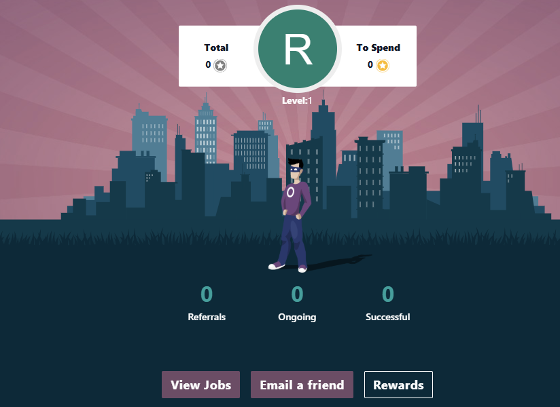

Sharing Job Positions
The core function of the Referrals app is enabling employees to share job openings with potential candidates. Employees can share jobs in multiple ways, and each method creates a unique tracking link so that when the candidate applies, the referral is automatically attributed to the employee who shared the position.

Viewing Available Jobs
Referrals Application => View Jobs
Clicking View Jobs on the dashboard displays all currently published job positions. Each job card shows the job title, number of open positions, total points that can be earned if the referral is hired, and the job description.
Only published job positions appear in the Referrals app. Job positions must be published through the Recruitment application for them to be visible here.

Sharing via Email
On any job card, click the Send button and then from the dropdown select Send by Email. A preconfigured email template opens with the subject line "Job for you" and a personalised tracking link to the job position. Enter the recipient's email address and send.
When the recipient clicks the link, they are directed to the job listing page on the company website. If they apply, the applicant card in the Recruitment pipeline is automatically linked to the referring employee.
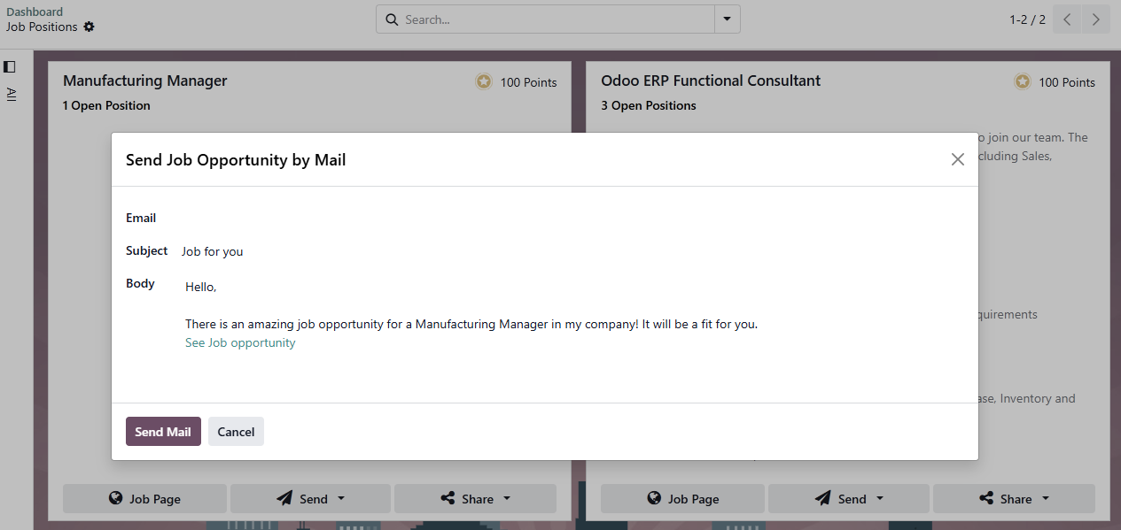

Sharing via SMS
Click the Send SMS button on the job card and then from the dropdown select Send by SMS. Enter the recipient's mobile number and send the prepopulated message containing the tracking link.
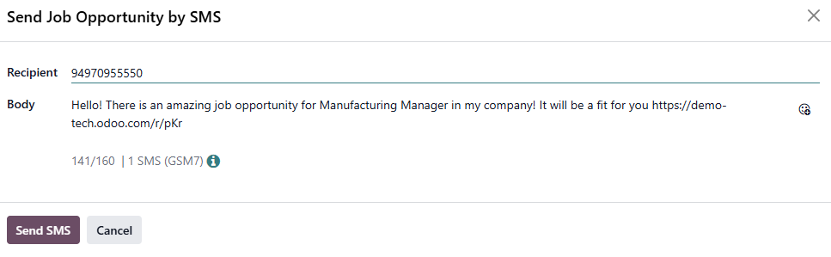

Sharing via Tracking Link
Click the Share button on the job card and then from the dropdown select Copy Link to copy a unique tracking link to the clipboard. This link can then be shared through any medium — messaging apps, forums, personal websites or any other channel. The link maintains the referral attribution regardless of where it is shared.

Sharing via Social Media
Click the Share button on the job card and then from the dropdown select any of the following:
- Facebook — Click the Share on Facebook to open a new tab with a draft Facebook post containing the tracking link. The user must be logged into Facebook for this to work.
- X (formerly Twitter) — Click the Share on X to open a new tab with a pre-drafted post. The user must be signed in to X.
- LinkedIn — Click the Share on LinkedIn to open a new tab where the job can be shared as a public post or a private message. The user must be logged into LinkedIn.

Sharing All Jobs at Once
Instead of sharing individual positions, employees can share the complete list of open jobs.
Referrals Application => Email a friend
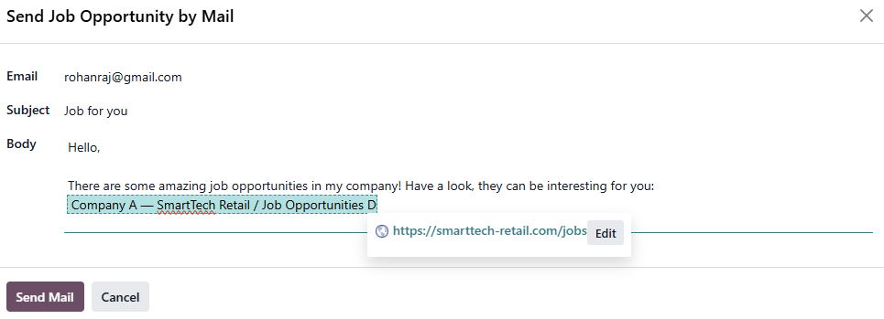
A preconfigured email template opens with a tracking link to all active job positions. Multiple recipients can be added by separating email addresses with commas. Edit the message if needed, then click Send Mail.

Referral Points System
The Referrals app uses a points-based system to incentivise employees. Points are earned automatically as a referred candidate progresses through the recruitment pipeline stages. The points are configured on each recruitment stage and can be customized by the administrator using the recruitment app.

Viewing Points
The employee's current points are displayed on the Referrals dashboard:
- Total — Lifetime points earned across all referrals
- To Spend — Points available for redeeming rewards

My Referrals
Referrals Application => Referrals (on dashboard)
Clicking Referrals on the dashboard opens the My Referral page showing all the employee's referrals. Each referral card displays:
- The applicant's name
- The application title
- The job position
- The recruiter responsible
- Points earned so far
- A progress bar showing points earned versus total possible points
- A checklist of recruitment stages with green checkmarks for completed stages
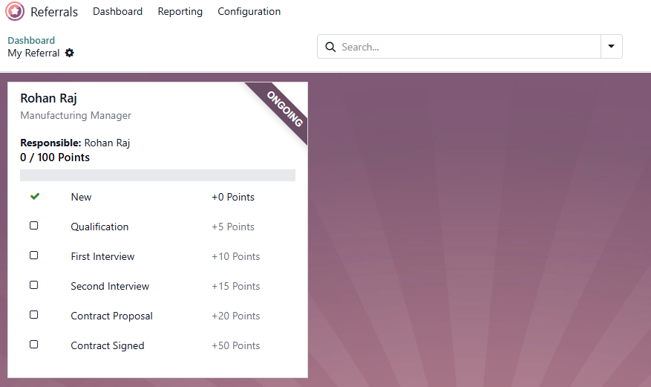

Levels and Gamification
The Referrals app includes a levelling system that adds a gamification layer to the referral process. As employees accumulate points, they level up, and their avatar on the dashboard changes to reflect their current level.

How Levels Work
- The user's current level is displayed beneath their photo on the dashboard
- A coloured ring around the user's photo shows progress toward the next level
- When enough points are accumulated to level up, the ring fills completely and a LEVEL UP! message appears
- Clicking the message upgrades the avatar to the new level

Modifying Levels
Referrals Application => Configuration => Levels
Administrators can modify the level names, point thresholds and avatar images.
Each level has a Level Name field and a Points field specifying the total accumulated points needed to reach that level.
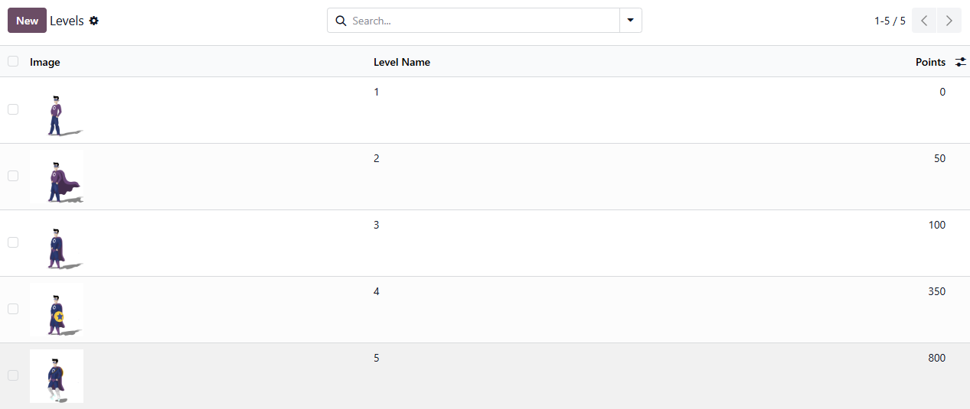

Hired Referrals and Avatars
When a candidate referred by an employee is hired, the employee "grows their superhero team" on the dashboard. The next time the employee opens the Referrals app, instead of the main dashboard, a special screen appears with the message:
(REFERRAL NAME) HAS BEEN HIRED! Choose an avatar for your new friend!
The employee selects an available avatar for their hired referral. Once an avatar is assigned, the dashboard loads with the new friend avatars visible alongside the user's own avatar.

Modifying Friend Avatars
Referrals Application => Configuration => Friends
Administrators can modify the friend avatars, including the Friend Name, Dashboard Image, Image (thumbnail) and Position (Front or Back).
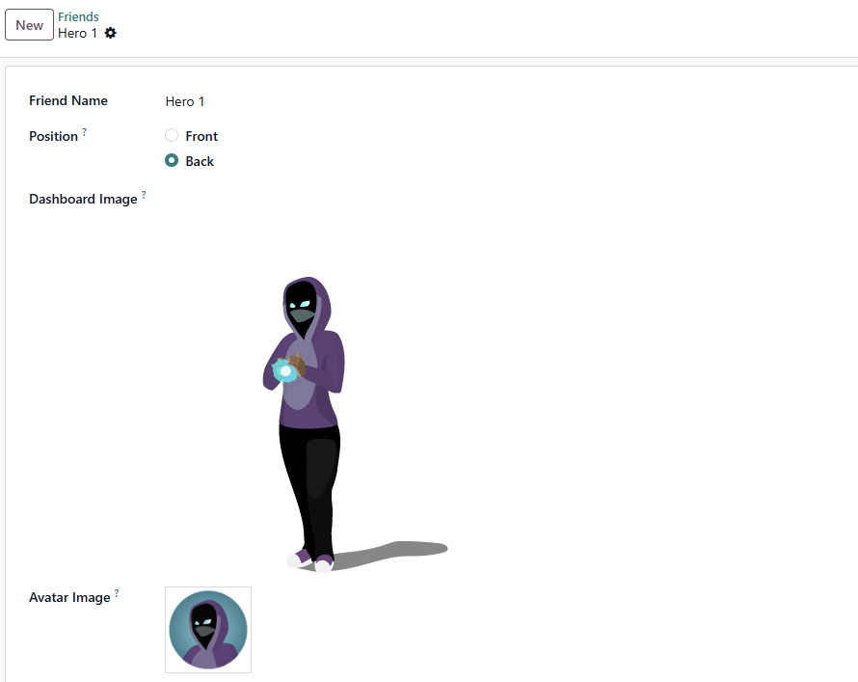

Rewards Configuration and Redemption
The Referrals app includes a rewards shop where employees can exchange their earned points for prizes. Rewards must be created and configured by an administrator before employees can redeem them. Rewards are the only configuration required after installing the Referrals app — everything else is preconfigured.

Creating Rewards
Referrals Application => Configuration => Rewards => New
On the reward form, configure the following:
- Product Name — The name of the reward as it appears in the shop. This field is required.
- Cost — The number of points required to redeem the reward. If left at zero, the reward appears as free in the shop.
- Gift Responsible — The person responsible for procuring and delivering the reward. This person is automatically notified when an employee purchases the reward, so they know when to arrange delivery.
- Photo — An image of the reward displayed on the reward card. If not set, a placeholder icon appears.
- Description — A description visible on the reward card beneath the title. This field is required.
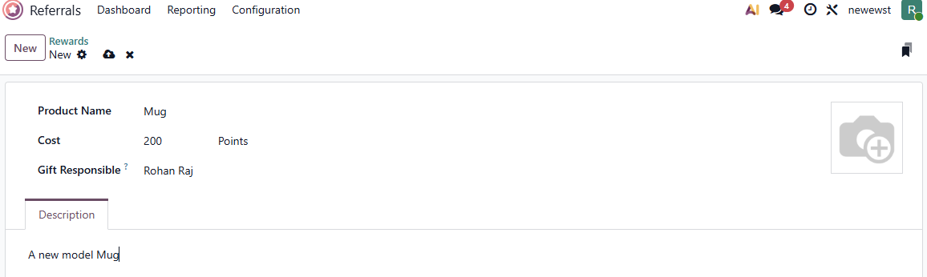

Redeeming Rewards
Referrals Application => Rewards
Clicking Rewards on the dashboard opens the rewards shop. Each reward card displays the reward name, photo, description and the points required in the top-right corner. If the employee has enough points, a Buy button appears at the bottom of the card
Clicking Buy opens a confirmation popup. Clicking Ok completes the purchase and deducts the points from the employee's available balance. The Gift Responsible person is automatically notified to arrange delivery of the reward.
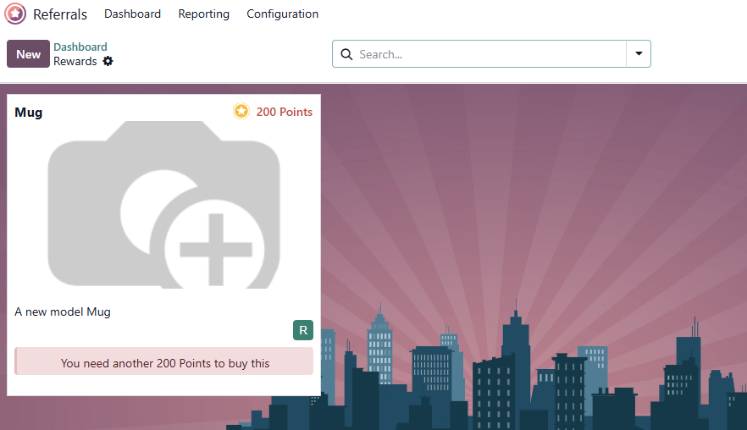

Alerts
Administrators can post alert banners on the Referrals dashboard to communicate important information to all employees, such as bonus point campaigns, new job openings or program updates.

Creating Alerts
Referrals Application => Configuration => Alerts => New
Configure the following fields:
- Alert — The text message displayed in the banner on the dashboard
- Date From — The date the alert becomes visible
- Date To — The date the alert is hidden
- Company — Restrict the alert to a specific company (leave blank to show to all users). This field only appears in multi-company databases.
- On Click — Choose the behaviour when the alert is clicked:
- Not Clickable — The alert only displays text
- Go to All Jobs — Clicking the alert navigates to the jobs page on the website
- Specify URL — Clicking the alert navigates to a custom URL
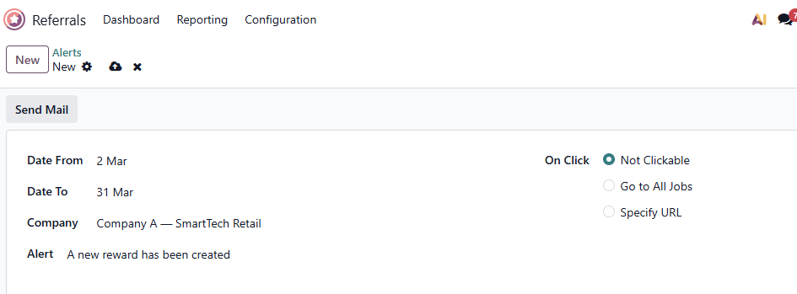

Notifying Users
After creating an alert, click the Send Mail button to email all users about the new alert. The email contains a link to the Referrals dashboard with the default subject "New Alert In Referrals App".

Dismissing Alerts
Employees can dismiss individual alerts by clicking the close icon on the alert banner. Once dismissed, the alert will not reappear for that user.

Reporting and Analytics
The Referrals app provides three reporting views to help administrators analyse the effectiveness of the referral program.

Referral Analysis
Referrals Application => Reporting => Referral Analysis
The Employees Referral Analysis report gives an overview of all referral activity, showing how many applicants were referred and their current status (Hired, In Progress or Not Hired). It is available in both graph and pivot views and can be filtered and grouped in various ways to analyze referral performance.
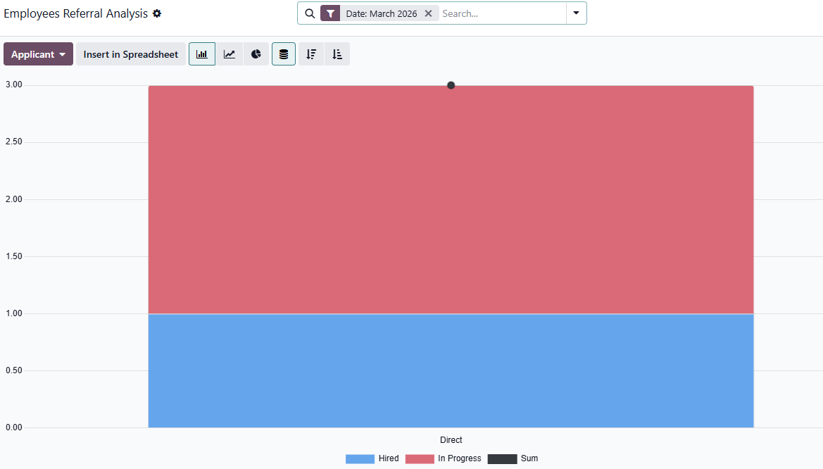

Points Report
Referrals Application => Reporting => Points
The Points report tracks all referral points earned and spent by employees. It shows point entries for each recruitment stage progression as well as reward redemptions, giving a complete picture of an employee's referral activity.
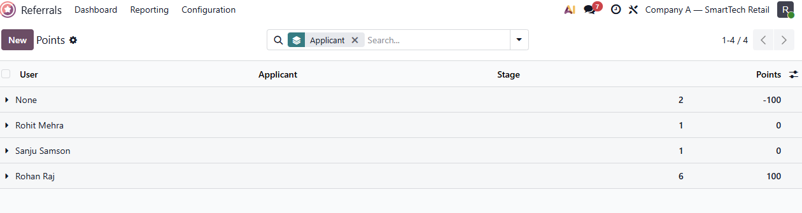

Rewards Report
Referrals Application => Reporting => Rewards
The Reward Analysis report shows which rewards have been redeemed and by whom. This helps administrators understand which rewards are most popular and ensure adequate stock of high-demand items.
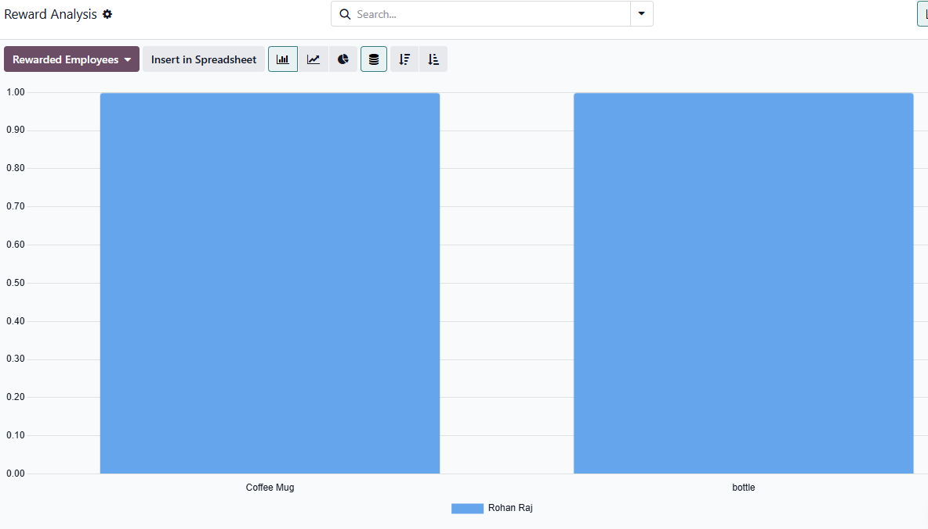

Conclusion
In a job market where finding the right person is harder than ever, the people already inside an organization are one of the most underused hiring resources available. Odoo 19 Referrals application makes it easy to tap into that network — not just once, but consistently, with every job that opens. It transforms employee referrals from an informal, untracked process into a structured, gamified program fully integrated with the recruitment pipeline. This kind of structured, ongoing employee participation in hiring is what separates companies that struggle to find good people from those that rarely have to look very far.

